import React, { useState, useContext } from 'react';

import { data } from '../../../data';

*// more components*

*// fix - context api, redux (for more complex cases)*

const PersonContext = React.createContext(); **\*\*\**creating context***

*// two components - Provider, Consumer*

const ContextAPI = () => {

const [people, setPeople] = useState(data);

const removePerson = (id) => {

setPeople((people) => {

return people.filter((person) => person.id !== id);

});

};

return (

<PersonContext.Provider value={{ removePerson, people }}>

<h3>Context API / useContext</h3>

<List />

</PersonContext.Provider>

);

};

const List = () => {

const mainData = useContext(PersonContext); ***\*\*\*useContext will use the context***

console.log(mainData);

return (

<>

{mainData.people.map((person) => {

return <SinglePerson key={person.id} {...person} />;

})}

</>

);

};

const SinglePerson = ({ id, name }) => {

const { removePerson } = useContext(PersonContext);

return (

<div className='item'>

<h4>{name}</h4>

<button onClick={() => removePerson(id)}>remove</button>

</div>

);

};

export default ContextAPI;

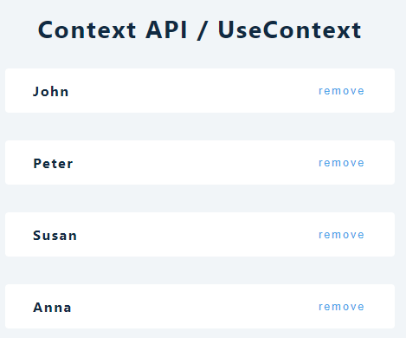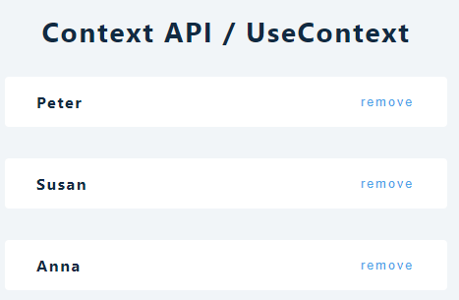

**Project:**



